Dokumentennummer / Document Number | 0103-194825 | Fertig gestellt / finalized
Version / Version | 00 | Fertig gestellt / finalized
Ersteller / Created by | Esber Isshak | Fertig gestellt / finalized
Erstellt Datum / Created Date | 13.11.2019 | Fertig gestellt / finalized
Dokumentenname / Document name | Tender template SOLOASSIST IIS - EN | Fertig gestellt / finalized
Ablageort / File | 1D59A48161FEE43 | Fertig gestellt / finalized

Funktion | Name | Datum | Signatur | Vermerk

Version / version | Änderung / Changes | Name / name | Datum / Date
00 | Erstellung / created

Dokumententitel

SOLOASIST IIS ACTIVE ASSISTENCE SYSTEM FOR LAPAROSCOPIC SURGERY

Pos. | Description | Recommended  Quantity
(A) | SOLOASSIST IIS - Field of Application  - GENERAL SURGERY  - UROLOGY  - GYNECOLOGY | -
(B) | SOLOASSIST IIS ROBOTIC ARM SYSTEM  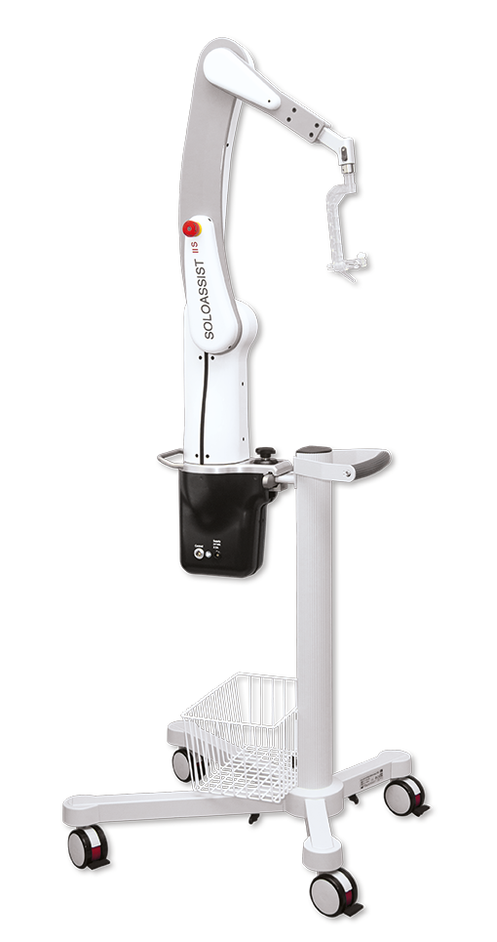  For precise robotic movement and manual positioning  of the endoscope during laparoscopic surgery. Mounted direct to the OR Table with an quick connection clamp, suitable for any standard OR Table.  SOLOASSIST IIS - Moving Axis:  - 3x driven electromechanically  - 1x passive universal joint  SOLOASSIST IIS - Movement Range:  - Zoom: > 400 mm  - Rotation: 360° multi-turn  - Inclination: +/- 90 °  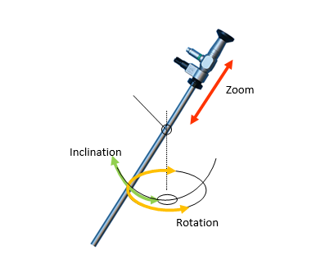  The system can placed free on the OR table. No fixed position in respect to the Trocar used for endoscope.  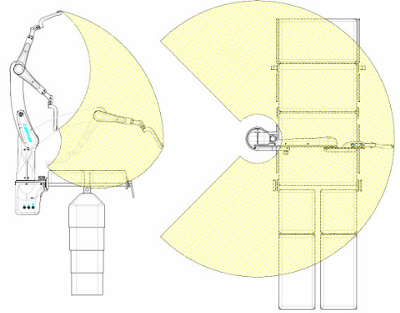  All control elements are integrated in the SOLOASSIST ARM SYSTEM in surgeons reach:  - Button “TP Set”  - Button “Manual movement”  - LED for TP, Service  - Emergency Stop  Connection socket for power supply and Voice Control SIIVoice  Power supply and cable and power cord (EU) included  Rated Voltage: 100-240V ~ / 47-63 Hz  Rated Power: 50 VA  Weight: 10,4 kg  All software included, no external control unit.  Transport Trolley included | 1
(C) | SOLOASSIST IIS - SYSTEM OVERVIEW  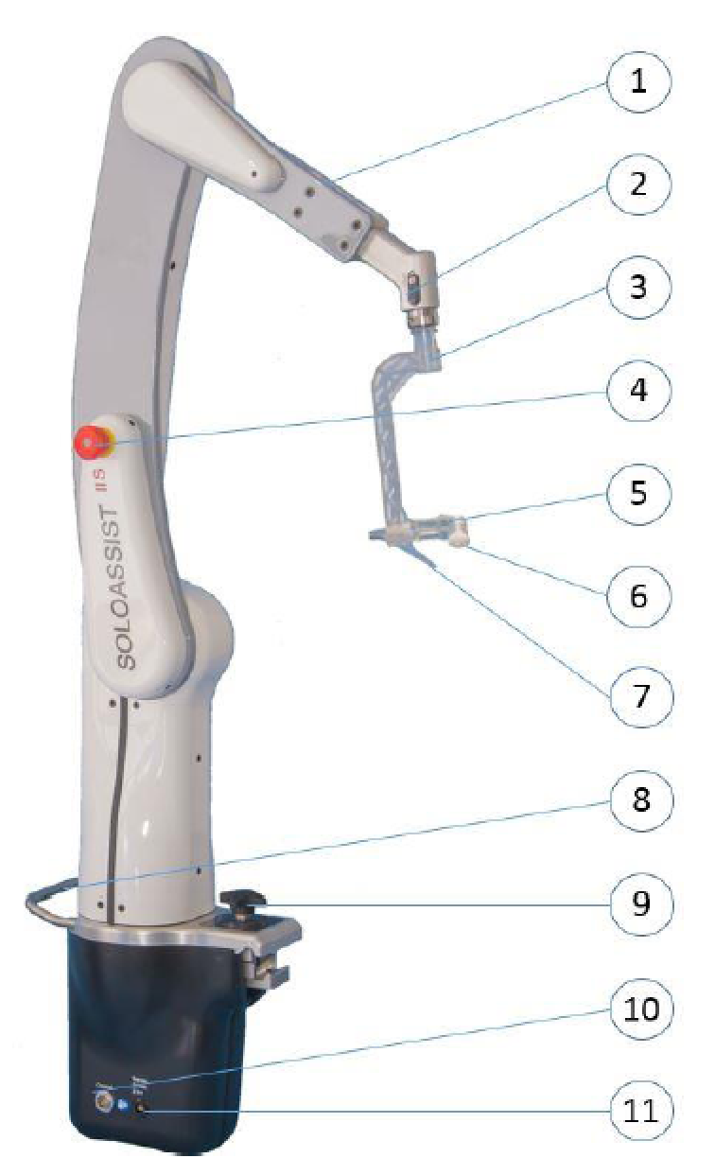  1 Control panel  2 Releasing slider  3 UNIVERSAL JOINT  4 EMERGENCY STOP  5 CLAMP  6 KNURLED NUT  7 STYLUS TIP  8 Handle  9 Quick-fastener for fastening to the operating table  10 Connection VOICE CONTROL  11 Connection POWER SUPPLY | -
(D) | SOLOASSIST IIS – Voice Control SIIVoice  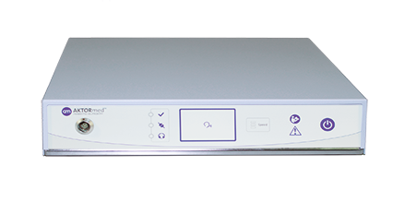  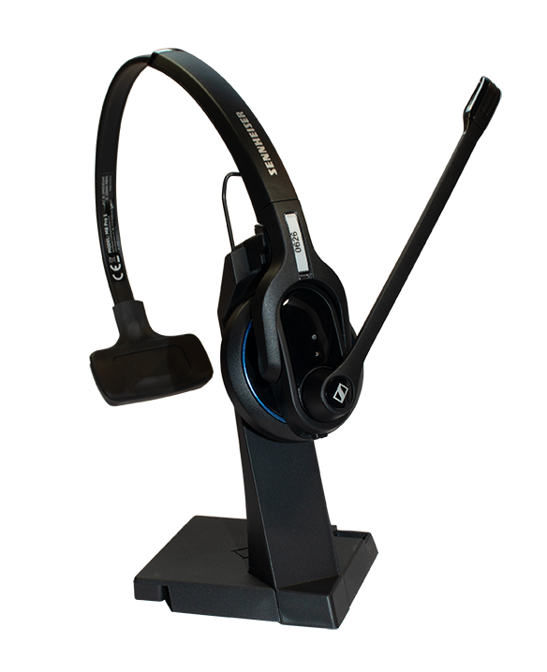  SIIVoice - Voice control system consists of:  - Control Unit  - Wireless headset  - Software included  - Connection cable to SOLOASSIST  SIIVoice - Key features  - Speaker independent - no speech training needed  - high responsive - average speech-to-movement time less than 200 ms  - precise – more than 95% recognition rate  SIIVoice – Functions “Moving the endoscope  The Voice Command Set allows precise control over the positioning of the endoscope during surgery. Each command sequence starts with the keyword "SOLO". Once this keyword has been recognized, commands are accepted within 10 seconds. During this period, the "Voice input" indicator lights green.  Display Status – Standby    Display Status – Active    The keyword has been recognized, the VOICE CONTROL is now ready to accept commands, which are then executed by the SOLOASSIST IIS. 10 seconds after the last detected command, the VOICE CONTROL returns to standby mode.  SIIVoice - Motion commands of the VOICE CONTROL  A motion command consists of direction (LEFT, RIGHT, UP, DOWN) or zoom (IN, OUT), and distance (ONE, TWO, THREE, FIVE, TEN). The direction can be modified to 45° with the command words UPPER and LOWER. The keyword MOVE repeats the last movement.  All directions refer to the monitor image. Pay attention to the anatomically correct adjustment of the image horizon.  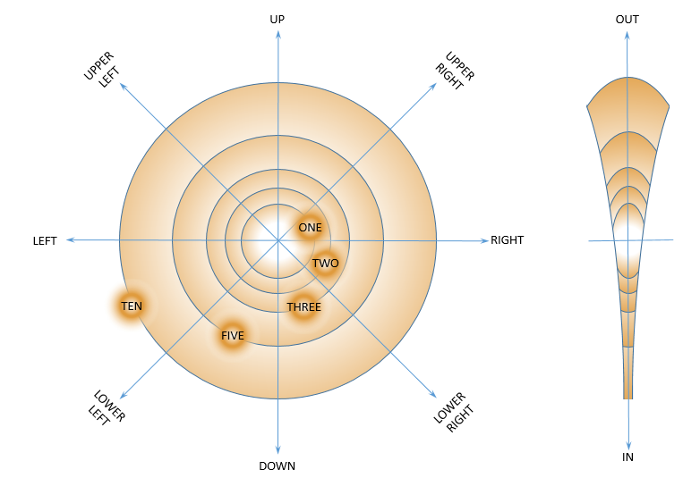  Saving positions  Sometimes it may be helpful to memorize a special endoscope position. With the SAVE and RESTORE keywords you can save up to three positions and restore this view when needed. With RETURN it is possible to undo the last movement.  SIIVoice - Motion commands “exemple”  Desired image change------------------------------- Requiered command  Image to the right -------------------------------------------------ONE RIGHT  Image to the left -----------------------------------------------------ONE LEFT  Image up -----------------------------------------------------------------ONE UP  Image down --------------------------------------------------------ONE DOWN  Image 45° upwards to the right -----------------------ONE UPPER RIGHT  Image 45° upwards to the left ---------------------------ONE UPPER LEFT  Image 45° downwards to the right ------------------ONE LOWER RIGHT  Image 45° downwards to the left ----------------------ONE LOWER LEFT  Overview ---------------------------------------------------------------ONE OUT  Detail view ----------------------------------------------------------------ONE IN  Repeat movement -------------------------------------------------------MOVE  Speed settings  With the SPEED keyword followed by ONE, TWO or THREE the speed of the movements of the SOLOASSIST can be adjusted to three pre-set speeds. |  | 1
(E) | SOLOASSIST IIS - STERILE SET consists:  - ENDOSCOPE HOLDER SET (1pcs)  - STERILE COVER (1pcs)  Endoscope Holder SET consists:  - Universal Joint  - Endoscope Clamp Ø10mm  - Endoscope Clamp Ø5mm  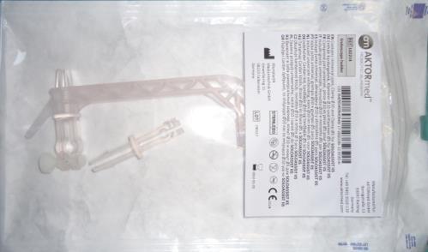  Sterile Cover – for covering the robotic arm  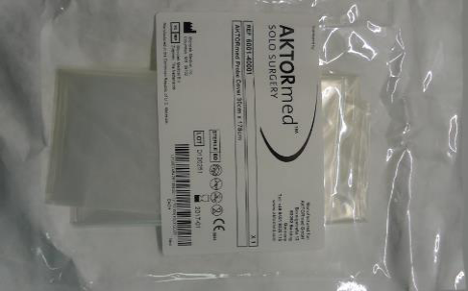  SOLOASSIST IIS - STERILE SET – Key Features  The universal joint connects the endoscope clamp with the robotic arm.  The Universal Joint is single use  SOLOASIST IIS Endoscope Clamp Ø10 mm  The CLAMP Ø10 can safely accommodate all endoscopes with an outer diameter of 8 to 11 mm, regardless the view angle of the endoscope (0°, 30°,…)  The endoscope clamp is single use  SOLOASIST IIS Endoscope Clamp Ø5 mm  The CLAMP Ø5 can safely accommodate all endoscopes with an outer diameter of 4 to 6 mm, regardless the view angle of the endoscope (0°, 30°,…)  The endoscope clamp is single use |  | 1 SET per procedure  1 per procedure  1 per procedure  1 per procedure  1 per procedure

