PASSIVE (Manual adjusted) ASSISTENCE SYSTEM FOR LAPAROSCOPIC SURGERY

- GENERAL SURGERY
- UROLOGY
- GYNECOLOGY
- ENT Surgery

Pos. | Description | Recommended  Quantity
1 | ENDOFIX EXO ARM SYSTEM  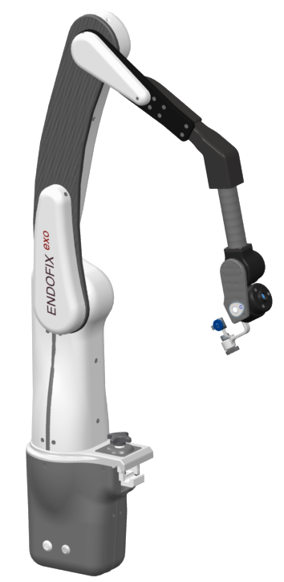  For precise manual positioning of an endoscope during laparoscopic surgery. Mounted direct to the OR Table with an quick connection clamp, suitable for any standard OR Table.  Moving Axis:  - 6x electromechanically locked  Movement Range:  - 400 x 400 x 400 mm  The endocope with camera head is largely weight balanced within the movement range.  The system can placed free on the OR table. No fixed position in respect to situs is needed  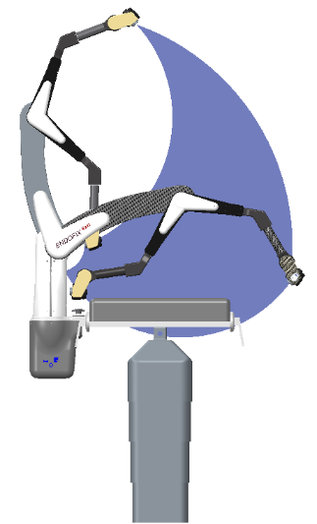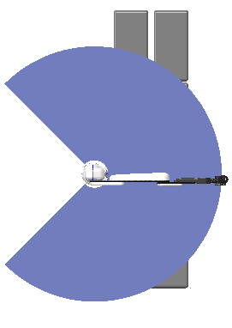  Connection socket for power supply and control button.  Power supply and cable and power cord included  Rated Voltage: 100-240V ~ / 47-63 Hz  Rated Power: 60 VA  Weight: 12,4 kg  No external control unit.  Transport Trolley included  All control buttons within the reach of the surgeon.  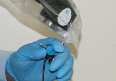  Sterile button to unlock the system.  Free floating movement when unlocked. | 1

2 | ENDOFIX EXO CONTROL button  The CONTROL is used to unlock the arms of the ENDOFIX EXO at the push of a button.  The CONTROL is autoclavable with a service life of min. 150 cycles.  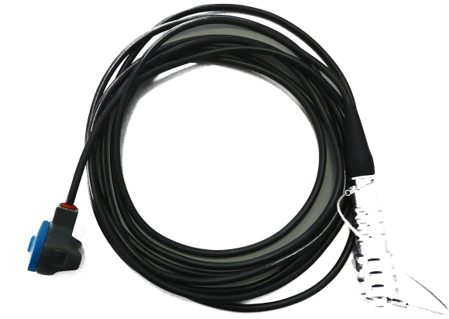  Connection cable to the arm is included | 2
3 | ENDOFIX EXO ENDOSCOPE CLAMP  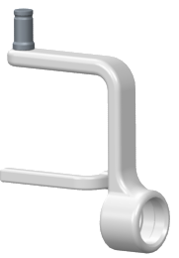  The ENDOSCOPE CLAMP features a self-acting lock into the quick coupling. It forms the connection between the ENDOFIX EXO and the TENSION SLEEVE.  The universal joint is full autoclavable | 2
4 | ENDOFIX EXO TENSION SLEEVE  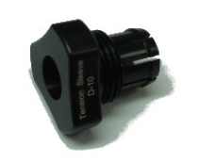  The TENSION SLEEVE accommodates the endoscope with a shaft diameter of 10 mm safely and gently. Endoscopes with smaller shaft diameters are accommodated by the CONE ADAPTER in the TENSION SLEEVE.  The endoscope holder is full autoclavable | 2
5 | ENDOFIX EXO CONE ADAPTER  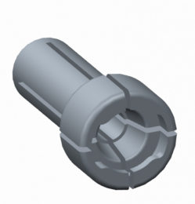  The CONE ADAPTER - matching the TENSION SLEEVE – accommodates endoscopes with connection cones acc. to Karl Storz. Appropriate variants exist for different connection cones.  The endoscope holder is full autoclavable | 2
6 | ENDOFIX EXO Cleaning sieve  For steam sterilization (autoclave) of the autoclavable SOLOASSIST components  With inserts for  - Control  - Universal joint  - Tension Sleeve  - Cone Adapter | 2
7 | ENDOFIX EXO Sterile drape  For covering the robotic arm | 1 per procedure

The positions reached by the SOLOASSIST depend on the select position of the additional joint as well as the positioning at the operating table

